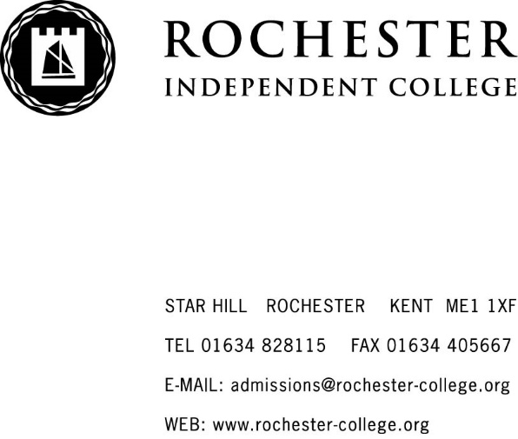
GOOD BEHAVIOUR AND SANCTIONS POLICY
2018/2019

The College welcomes students from a variety of backgrounds and cultures. It is an important part of the College ethos that we show mutual respect and treat others how we would like to be treated ourselves. We want everyone to feel comfortable and happy in the College environment, which means behaving in an acceptable manner. We are all expected to behave sensibly and responsibly at all times, both in and out of the classroom. This would include school journeys and instances when students are off site but under the supervision of the College.

The rules for the College can be found in the planners for years 7 to 11, in the sixth form handbook for those in years 12-14 who are day students and also in the boarding handbook for boarding students. Students are expected to follow the school rules as well as instructions and directions given by all members of staff, whether teaching, boarding or non-teaching.

Building good relations between staff and students helps to develop trust and respect. This goes a long way to anticipating a potential problem before it becomes a significant one. Furthermore, a timely conversation between a member of staff to a student’s form teacher or personal tutor is an effective way of helping a minor problem stay that way. This means that in many instances there will in fact be no need for sanctions.

This policy is written with due regard to the DfE guidance ‘Behaviour and Discipline in Schools’ 2016 and also the Equality Act 2010. Students with SEND are given due consideration. In response to challenging behaviour displayed as a result of their disability positive discipline and reward may help to motivate them to behave better.

The College promotes good behaviour through

- staff themselves setting high standards so that students can follow their example
- strong senior leadership
- strong classroom management
- staff applying rules firmly and fairly
- getting to know the students well
- consistently praising
- staff careful listening and reassuring students that we are trying to understand their problem
- being good-humoured and even-tempered
- dealing quickly with instances of poor behaviour
- support systems in school for students eg through the form teacher, personal tutor, safeguarding officers or nurse
- partnership with parents and outside agencies

Good behaviour is taught through
- PHSE in the lower school, where morals are discussed and explored
- Sport, which encourages fairness and team spirit
- Huddle time in the lower school, which emphasises the College’s behavioural expectations
- The merit system in the lower school, with points awarded for good behaviour
- Disciplinary action, to demonstrate to the student the difference between right and wrong as well as the consequences of our actions
- Support from form teachers, personal tutors, safeguarding offices, the nurse and our SENCo

Acceptable/Unacceptable behaviour is listed below but this is not exhaustive and includes communication via text and internet, as well as in person:

Acceptable behaviour

- being courteous
- being polite
- being respectful
- being honest
- respecting other people’s belongings
- being considerate of others’ feelings
- being tolerant
- being helpful
- being punctual
- paying attention
- being prepared for lessons

Unacceptable behaviour

- rudeness
- ridiculing others
- lying
- stealing
- spitting
- threatening behaviour
- unwanted touching
- inappropriate displays of affection
- ignoring direct instruction from member of staff
- interfering with College property (eg vandalism, graffiti, setting off fire alarm deliberately)
- interfering with another student’s property
- starting rumours
- inattention in lessons
- persistent lateness
- not following procedure
- chewing gum

Praise from Personal Tutors or other members of staff will always boost a student’s morale, where rewards can be more effective than punishment as motivation. Praise can be given for good behaviour, abiding by the rules where previously a student may have received a warning, or for producing a piece of good work. Again, the list is not exhaustive.

Where praise is awarded, students can be given some form of reward, which may be in the form of:
- displaying of the student’s working within College
- contacting parents/guardians to advise of improved behaviour
- special mention in student’s report
- feature a personal achievement in the College newsletter

In the Lower School there is a merit system by which students can earn Merits for outstanding work, effort or contribution to College life. Those students who are identified as having the highest merit count at the end of the term are rewarded in various ways including extra-curricular trips, certificates and lunches. Individual year groups and forms are rewarded in similar ways for accruing the most merits in comparison to other groups and forms in the Lower School.

Minor problems or incidents are dealt with initially at personal tutor level and records kept in the student’s file. A record of serious sanctions is kept by the College which can be found in the administrator office in Star Hill. The use of sanctions and rewards is monitored by senior leaders to ensure effective and consistent implementation of this policy.

Students in Years 7-11 may be given the following sanctions:
- a report card, signed by teachers at the end of every lesson as proof of good behaviour
- helping tidying classrooms and generally around the buildings

A level students may be given the following sanctions:
- signing in with a Sixth Form Administrator for persistent lateness or similar
- working under supervised conditions
- clearing up an area that students have left untidy

Boarders may be given the following sanctions:
- confiscation of speakers/music system if music being played too loud
- irregular room being checked to ensure it is being kept clean and tidy
- signing in with Boarding staff each hour during the evening if they have been grounded

Students are generally polite and well-behaved, but there may be times when it is necessary to deal with more serious breaches of behaviour. Examples include but are not restricted to:
- persistent class disruption
- repeatedly ignoring a direct instruction from a member of staff
- bullying
- stealing
- vandalism
- possessing or under the influence of drugs
- possessing or under the influence of alcohol
- smoking in Boarding
- repeatedly not signing out of Boarding
- repeatedly ignoring Boarding room check times
- leaving room persistently untidy

Although students may receive a sanction for misbehaviour, we also want to help and support them so that they are aware that their behaviour is not acceptable and not to misbehave again. This may be achieved by discussing the situation; emphasising the wrongdoing and the need to change conduct and talking through the effect the poor behaviour has on others.

In accordance with the law, we do not practise corporal punishment; nor will it be threatened under any circumstances. It may however be necessary for a member of staff to intervene to physically restrain a student to prevent them from coming to harm, injuring themselves or others; damaging their own or others’ or College property; or engaging in behaviour that obstructs good order and discipline at the College or amongst its students in the classroom and elsewhere in the College, including authorised activities outside College. This will be carried out with the minimum necessary to restore order to the situation and following the guidance given in the DfE publication Use of reasonable force in schools July 2013.
A case such as this must be reported to the principal and also recorded and filed in the use of reasonable force folder kept in the administration office in Star Hill.

The College operates a four-step disciplinary procedure for more serious problems; the following steps apply:

Verbal warning
This is given by the Form/Personal Tutor and/or College Principal. Parents/guardians will be given written notification of the warning.

First written warning
Parents/Guardians may be asked to come into College to see the Form/Personal Tutor and/or the College Principal. The student and parent/guardian will be asked to sign the warning letter, keep a copy themselves and a copy kept on the student’s file.

Second written warning
Parents/Guardians asked to come into College to see the Form/Personal Tutor and the College Principal.

At this stage, the parent/guardian and student will be advised that any further breaches of College rules and regulations may result in a fixed term or permanent exclusion.

The student and parent/guardian will be asked to sign the warning letter, keep a copy themselves and a copy kept on the student’s file.

Fixed-term/Permanent exclusion
It may be necessary for the student to be sent home for a period of time as decided by the College Principal. This would be a fixed-term exclusion. Parents/Guardians will be advised that a fixed-term exclusion is being made and may be asked to collect the student from College premises.

The Principal’s decision to permanently exclude a student is not taken lightly. It usually follows a number of disciplinary offences and parents/guardians and student will have been warned that this may occur. The most serious infringements include, but are not limited to, the following:
- vandalism
- possession and/or use of an offensive weapon
- possession and supply of drugs
- possession and supply of alcohol
- sexual abuse or assault
- violence (actual or threatened) against a student or member of staff
- bullying
- theft
- persistent attitude and/or misbehaviour that is not in keeping with College ethos
- any other issue of misconduct with brings College into disrepute

Notes
Unless otherwise advised, if the student maintains good behaviour for four academic weeks, ie working days, not weekends or holidays, the student will drop a stage or off the scale completely as applicable.

For very serious problems or incidents it may be appropriate to move immediately to Steps Two, Three or Four. There may be occasions when special extenuating circumstances need to be considered, so a lesser sanction may be applied. Appropriate sanctions, including loss of free time or temporary/fixed-term exclusions may be enforced at any of the first three stages in the process. Minor misdemeanours may merit a sanction without the student necessarily moving up a stage on the Disciplinary process.

Appeals against any disciplinary decisions made by the College are governed by the Complaints Procedure.

Created/Updated | Author | Approved by | Date
August 2017 | ME & KF | AB | August 2017
August 2018 | ME | AB | September 2018

