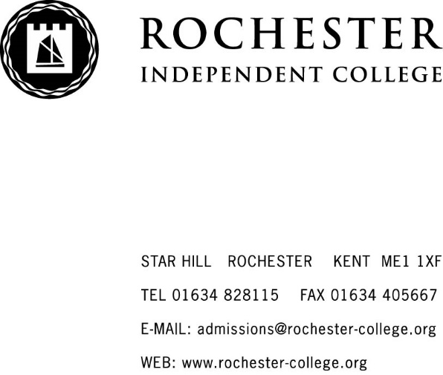
GOOD BEHAVIOUR AND SANCTIONS POLICY
2017/2018

The College welcomes students from a variety of backgrounds and cultures. It is an important part of the College ethos that we show mutual respect and treat others how we would like to be treated ourselves. We want everyone to feel comfortable and happy in the College environment, which means behaving in an acceptable manner. We are all expected to behave sensibly and responsibly at all times. Acceptable/Unacceptable behaviour is listed below but this is not exhaustive and includes communication via text and internet, as well as in person:

Acceptable behaviour

- being courteous
- being polite
- being respectful
- being honest
- respecting other people’s belongings
- being considerate of others’ feelings
- being tolerant
- being helpful
- being punctual
- paying attention
- being prepared for lessons

Unacceptable behaviour

- rudeness
- ridiculing others
- lying
- stealing
- spitting
- threatening behaviour
- unwanted touching
- inappropriate displays of affection
- ignoring direct instruction from member of staff
- starting rumours
- chewing gum
- inattention in lessons
- persistent lateness
- not following procedure
- interfering with College property (eg vandalism, graffiti, setting off fire alarm deliberately)

Praise from Personal Tutors or other members of staff will always boost a student’s morale, where rewards can be more effective than punishment as motivation. Praise can be given for good behaviour, abiding by the rules where previously a student may have received a warning, or for producing a piece of good work. Again, the list is not exhaustive.

Where praise is awarded, students can be given some form of reward, which may be in the form of:
- displaying of the student’s working within College
- contacting parents/guardians to advise of improved behaviour
- special mention in student’s report
- feature a personal achievement in the College newsletter
- scholarship or bursary
- accelerated programme of study for gifted and talented students
- move to ensuite accommodation at no extra cost for a boarder
- subsidised or free College excursion for boarders

Minor problems or incidents are dealt with initially at Personal Tutor level and records kept in the student’s file.

Students in Years 7-11 may be given the following sanctions:
- a report card, signed by teachers at the end of every lesson as proof of good behaviour
- helping tidying classrooms and generally around the buildings

A level students may be given the following sanctions:
- signing in with a Sixth Form Administrator for persistent lateness or similar
- working under supervised conditions
- clearing up an area that students have left untidy

Boarders may be given the following sanctions:
- confiscation of speakers/music system if music being played too loud
- irregular room being checks to ensure it is being kept clean and tidy
- signing in with Boarding staff each hour during the evening if they have been grounded

Students are generally polite and well-behaved, but there may be times when it is necessary to deal with more serious breaches of behaviour. Examples include but are not restricted to:
- persistent class disruption
- repeatedly ignoring a direct instruction from a member of staff
- bullying
- stealing
- vandalism
- possessing or under the influence of drugs
- possessing or under the influence of alcohol
- smoking in Boarding
- repeatedly not signing out of Boarding
- repeatedly ignoring Boarding room check times
- leaving room persistently untidy

Although students may receive a sanction for misbehaviour, we also want to help and support them so that they are aware that their behaviour is not acceptable and not to misbehave again. This may be achieved by discussing the situation; emphasising the wrongdoing and the need to change conduct, and talking through the effect the poor behaviour has on others.
In accordance with the law, we do not practise corporal punishment.

The College operates a four-step disciplinary procedure for more serious problems; the following steps apply:

Verbal warning
This is given by the Form/Personal Tutor and/or College Principal. Parents/guardians will be given written notification of the warning.

First written warning
Parents/Guardians may be asked to come into College to see the Form/Personal Tutor and/or the College Principal. The student and parent/guardian will be asked to sign the warning letter, keep a copy themselves and a copy kept on the student’s file.

Second written warning
Parents/Guardians asked to come into College to see the Form/Personal Tutor and a College Principal.

At this stage, the parent/guardian and student will be advised that any further breaches of College rules and regulations may result in a fixed term or permanent exclusion.

The student and parent/guardian will be asked to sign the warning letter, keep a copy themselves and a copy kept on the student’s file.

Fixed-term/Permanent exclusion
It may be necessary for the student to be sent home for a period of time as decided by the College Principal. This would be a fixed-term exclusion. Parents/Guardians will be advised that a fixed-term exclusion is being made and may be asked to collect the student from College premises.

The decision to permanently exclude a student is not taken lightly. It usually follows a number of disciplinary offences and parents/guardians and student will have been warned that this may occur. The most serious infringements include, but are not limited to, the following:
- vandalism
- possession and/or use of an offensive weapon
- possession and supply of drugs
- possession and supply of alcohol
- sexual abuse or assault
- violence (actual or threatened) against a student or member of staff
- bullying
- theft
- persistent attitude and/or misbehaviour that is not in keeping with College ethos
- any other issue of misconduct with brings College into disrepute

Notes
Unless otherwise advised, if the student maintains good behaviour for four academic weeks, ie working days, not weekends or holidays, the student will drop a stage or off the scale completely as applicable.

For very serious problems or incidents it may be appropriate to move immediately to Steps Two, Three or Four. There may be occasions when special extenuating circumstances need to be considered, so a lesser sanction may be applied. Appropriate sanctions, including loss of free time or temporary/fixed-term exclusions may be enforced at any of the first three stages in the process. Minor misdemeanours may merit a sanction without the student necessarily moving up a stage on the Disciplinary process.

Appeals against any disciplinary decisions made by the College are governed by the Complaints Procedure.

Created/Updated | Author | Approved by | Date
August 2017 | ME & KF | AB | August 2017
August 2018

